Estimate speed verification:

Estimate 6441

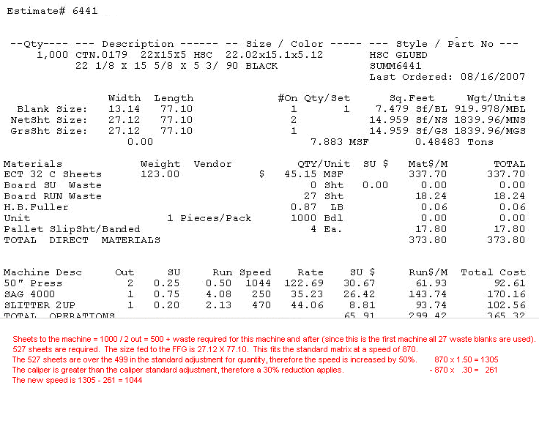

The net sheet size of 27.12 X 77.10 yields a base speed of 870 per hour. The quantity and caliper adjustments are then applied.

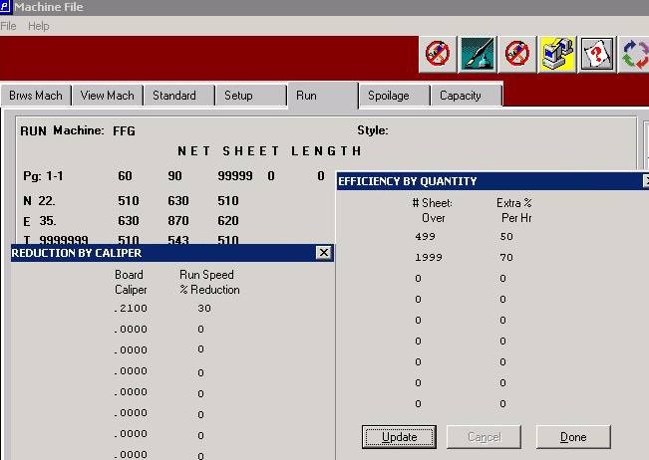

870 X 1.50 = 1305
LESS 870 X .30 = 261
Speed 1044

